Exam 3 Bonus Problem

Q.8.18

To solve this, we can use the equation for inelastic collisions, just reversed. Skater A will have a negative velocity since they will be heading in the opposite direction, however since they are starting from rest, their initial velocity is zero, therefore we can bring the Skater A’s mass and velocity over and make it positive. Then substitute in the values given and solve for A’s velocity. First convert the mass in Newtons to kg by dividing by gravity (9.8). The equation for kinetic energy is KE = ½ (mAvA^2 + mBvB^2). Sub in the values found/used in Part A and solve to find the KE produced in Joules. This is determined from both Part A and B, the work done is from one skater exerting a force onto the other. The other options are incorrect as in the brief it mentions that they both push off each other and not one pushes off the other while the other stands still and does nothing.

Q8.28

To calculate this problem, we must use the conservation of momentum. Since the person will be moving backwards in the x direction, we need the x-component of the rock’s velocity. This can be found by taking 12cos35 degrees to find the x-comp of the rock’s velocity. Then, since initial velocity is zero as both objects are at rest, and the person’s velocity will be negative, we can then set the momentum of the person equal to the momentum of the rock with the x-comp of velocity. Then sub in the give values and solve for the person’s velocity.

Q8.82

This problem requires using the conservation of mechanical energy equation where the change in mechanical energy equals 0, therefore the initial kinetic and potential energy equal the final kinetic and potential energy. Initial potential energy and final kinetic energy are set at 0 as the objects end at rest and start with some velocity. Final potential energy is simply mgh while the initial kinetic energy can be given as the sum of both masses multiplied by the velocity then divided by 2. Set initial kinetic energy equal to final potential energy and then solve for h. To find the initial velocity of the blocks, we simply use conservation of momentum for the blocks, given block 1 dropped from rest and fell due to gravity, and block 2 was still at rest, the combined final velocity after collision is found as square root of g times R over 2. Then sub in the value of v into the first equation where we had solved for height and then simplify, giving us h = R/4.

Q9.77

Again, conservation of mechanical energy. Initial kinetic and final potential equal 0, initial potential is mgd, final kinetic is the sum of kinetic energy of the two masses, the pulley, and friction in the opposite direction. Solve for the final velocity, subbing in Inertia.

Rotational Kinetic Energy and Conservation of Energy Ranking Task

To solve this problem, we need to use the conservation of mechanical energy formula to find the max height reached. Initial potential and final kinetic are 0 while the initial kinetic equals the rotational kinetic energy and the regular kinetic energy. Then solve for height. To find the various heights of each object, find the inertia by using the respective inertia formulas. Since velocity and the radius are the same for all, we only need to find the value in front of velocity to compare the four objects and their final height reached.

Q10.64

For this problem, we need to find the torque of the wheel and the torque of the crank. The torque of the wheel can be found by finding the force of the box exerting on the wheel, then using the torque formula, solve for torque. The torque of the crank is given by the Inertia of the crank multiplied by the acceleration of the box divided by the radius of the crank. Then find total torque by adding both torques together. To find force applied, have the total torque divided by the radius of the crank.

Pulling a String to Accelerate a Wheel

First to find angular acceleration we use the torque formula to set rF = I alpha. Then solve for alpha and sub in values for I. Since this is a no slip problem, omega = Fxd. Omega can be given as the rotational kinetic energy of the wheel. Solve for omega by bringing inertia over. To find the speed of the string, use the v=r omega formula as this is a non slip problem. Then sub in omega from the previous part and cancel out the r.

Unwinding Cylinder—Dynamics

Omega can be found as the velocity/radius. We know from a free body diagram; tension will equal mass time gravity minus mass time acceleration. Then using the torque formula, subbing in T for F, as T approaches 0, acceleration will equal gravity. So, T=0, a=g. On the other hand, if I approaches infinity, torque will also approach infinity, meaning T =mg and a =0 as there will be no rotation, the string can’t unwind, so net force equals 0. Then using the previous formula and free body diagram, T=mg. Torque equals -rT as through the right hand rule, if angular acceleration is negative, T must be in the negative direction. To solve for T, we must first find acceleration. This can be done through the torque formula by setting a = -r^2T/I. Sub in the found values of T. To solve for T, do the reverse.

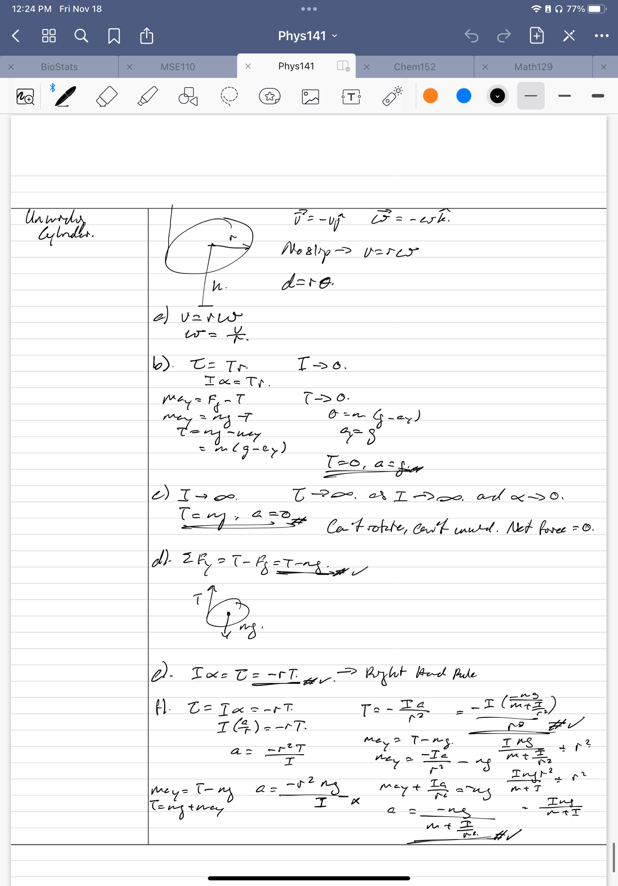

Balancing Torques Ranking Task

This problem we will use the torque formula. To find the F, we know the r and theta values based on the info given. Then, solve for F by taking the inverse of rsin(theta). Rank the F’s based on largest to smallest value.

Pivoted Rod with Unequal Masses

We need the total inertia which is given by the inertia of the rod and the inertia of both masses. To find angular acceleration, we need to use the torque formula, I alpha = rFg, with r=x. Then solve for alpha and sub in the give values. As the mass of the rod does not affect, and both spheres being opposite of each other, we find that the F = m1-m2.

